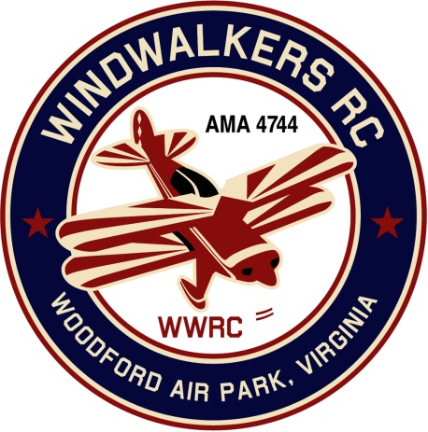
June 8, 2022
Monthly Club Meeting Minutes,
Club President, Gary Stone, called the meeting to order at 11:22 a.m., on June 8, 2022. The meeting was held at the Salem Library, Fredericksburg, VA. The meeting opened with the pledge of allegiance. There were six members in attendance.

Secretary’s Report:
- Last report dated May 14, 2022

Treasurer’s January/February Report:
- Beginning bank balance: $3,634.84
- Ending bank balance: $3,634.84

Field Safety Report:
- Nothing new to report

Old Business:
Our Static Display at the mall is scheduled for August 6th. It is the designated tax free day for back to school shopping. We have reserved the area next to Chick Filet for Saturday only.
  - Need better roping around planes to secure them from small children.
  - Hank suggested bringing old AMA magazines. Cindy and Gary have lots and will bring them.
- The suggestion to do an event for large scale planes and call it ‘The Leo Caton Fly Inn’ was dropped due to potential space/parking issues.

New Business:
- We scheduled our 2022 Scout Day. It will be September 17th. Mike will reconfirm with Scout Master.
  - Hank has another group of Scouts interested in joining the event. There are approximately (15-17) scouts in this new group. Mike will get a head count on our usual group.
- Aviation Day date has been tentatively set for August 27th.

Upcoming Events:
- Shannon Display is in October
- June 25, 2022 Float Fly in Bealton
- September 3, 2022 Float Fly in Bealton

There being no further business. The meeting adjourned at 11:55

Respectfully Submitted,

Cindy Stone

