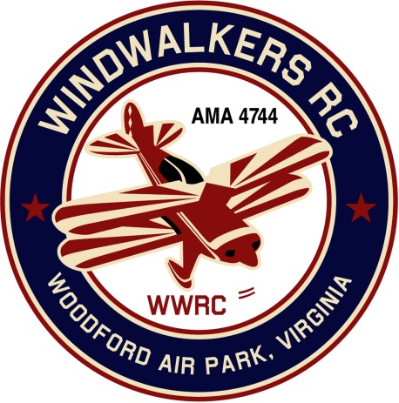
July 31, 2022
Monthly Club Meeting Minutes,
Club President, Gary Stone, called the meeting to order at 11:05 a.m., on July 31, 2022. The meeting was held at the Woodford Airpark in Woodford, VA. The meeting opened with the pledge of allegiance. There were five members in attendance.

Secretary’s Report:
- Last report dated June 8, 2022

Treasurer’s January/February Report:
- Beginning bank balance: $3,634.84
- AMA Mall insurance $25.00
- Ending bank balance: $3,609.84

Field Safety Report:
- Nothing new to report

Old Business:
August 6, 2022 is the static display at the mall. Hank suggested that we have maps available to the field. He was also concerned that there may not be enough roping.
It was decided to offer free membership if someone signed up at the event. This would be valid through 2022.
New Business:
- Scout Day is scheduled for September 17th. Mike reconfirmed with Scout Master they are not able to do the 17th. Hank said he would ask the Scout Master he has been in touch with.
- Aviation Day date has been tentatively set for August 27th.

Upcoming Events:
- Shannon Display is in October
- September 3, 2022 Float Fly in Bealton

There being no further business. The meeting adjourned at 11:45

Respectfully Submitted,

Cindy Stone

