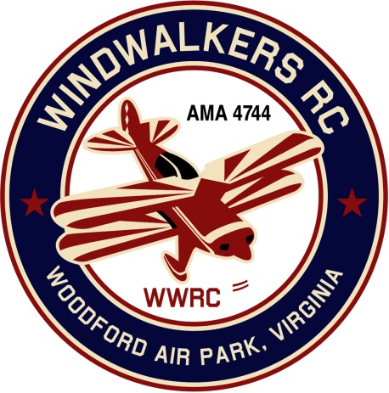
June 5, 2021
Monthly Club Meeting Minutes,
Club President, Gary Stone, called the meeting to order at 11:01 a.m. on June 5, 2021. The meeting was held at the Woodford Air Park in Woodford, VA. The meeting was opened with the pledge of allegiance. There were 9 members in attendance.

Secretary’s Report:
- Last report was dated May 15, 2021.

Treasurer’s Report:
- Beginning bank balance: $3,861.23
  - Gift Card: $31.01
- Ending bank balance: $3,830.22

Field Safety Report:
- Nothing new to report.

Old Business:
Preparations for Aviation/Scout Day:
  - We have three scout troops this year. Approximate head count is (35). Some scouts will be camping over night at the field.
  - Three club trainers will be needed. Gary, Dan & Eugene will provide them.
  - Ropes and barriers will be needed around all air crafts during this event.
  - Cindy will get food and essentials for the event.
  - Eugene will bring drinks, ice and coolers.
  - Dan will provide the cookies.
  - Gary will reach out to Johnny to see where we can get a Cessna for the day.
  - Wrist bands will be used for pilots and scouts. Scouts will eat free. If pilots intend to fly their meal is covered in the signup fee.
  - Gary will supply the generator and sound system.
  - There will be a 50/50 raffle.
  - (4) Door prizes (Gift cards Lowes and Visa)
- Porta jon will be pumped on Tuesday 6-22-21.
- Gary and Dan will go to field to clean up on 6-23-21.
  - Gary will purchase a lawn mower battery.

New Business:
  - Covered under planning for Aviation Day.

Upcoming Events:
- Leo Caton Aviation Day/Scout Day - June 26, 2021
- Joe Nall is scheduled for the fall in SC
- Bealton Float Fly will be in September.

There being no further business, the meeting was adjourned at 11:50 a.m.

Respectfully Submitted,

Cindy Stone

