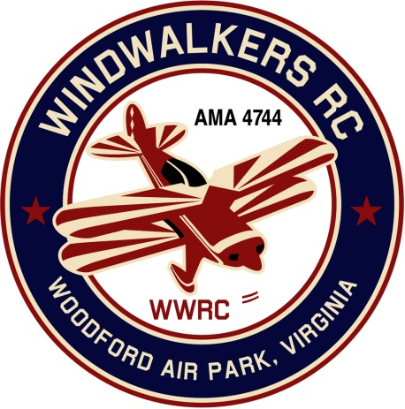
April 10, 2021
Monthly Club Meeting Minutes,
Club President, Gary Stone, called the meeting to order at 11:15 a.m. on April 10, 2021. The meeting was held at the Woodford Air Park in Woodford, VA. The meeting was opened with the pledge of allegiance. There were 8 members in attendance.

Secretary’s Report:
- Last report was dated June 13, 2020. All activities were suspended due to covid.

Treasurer’s Report:

- Beginning bank balance: $3,577.98
  - Annual Dues Deposited: $353.25
  - Checks written: AMA Charter $120.00
- Ending bank balance: $3,811.23

Field Safety Report:

- There is a FAA test with (25) questions. No concerns at this point.

Old Business:
- NA

New Business:
- A motion was made to combine the 2021 Scout day and Aviation day into one event. The motion was second and approved.
- The Scout master ask if they could camp out a weekend in May at the field. Gary will follow up with Johnny to get approval. Mike will provide Gary with a date.
- Cindy will call to have porta john pumped this week. Once scheduled she will call Dan and let him know date. Dan is going to go down and power wash the unit after it is pumped.
- Also at our Aviation day event we will hold a silent auction for Dennis Hagan’s donated equipment to the club.

Upcoming Events:
- Leo Caton Aviation Day/Scout Day - June 26, 2021
- Joe Nall is scheduled for the fall in SC
- Bealton Float Fly will be in September

There being no further business, the meeting was adjourned at 11:42 a.m.

Respectfully Submitted,

Cindy Stone

