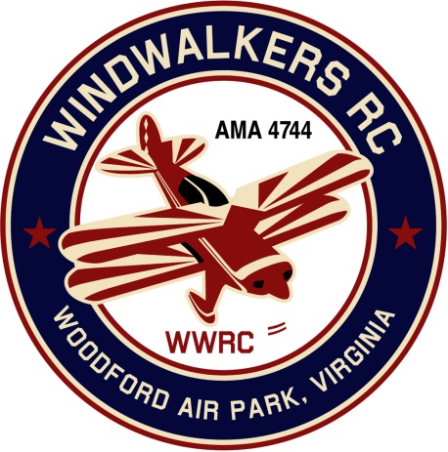
March 14, 2020
Monthly Club Meeting Minutes,
Club President, Gary Stone, called the meeting to order at 11:15 a.m. on March 14, 2020. The meeting was held at Salem Library in Fredericksburg, VA. The meeting was opened with the pledge of allegiance. There were 10 members in attendance.

Secretary’s Report:

- The meeting minutes from February 8th were read and accepted.

Treasurer’s Report:

- Beginning bank balance: $3,810.07
  - AMA Charter & Insurance $120.00
- Ending bank balance: $3,690.07

Field Safety Report:

- Hank brought a sample form of a ‘Hold Harmless’ agreement. Cindy will create a similar form for the club.

Old Business:
- AMA is talking about requiring knowledge exams. Hank is going to look in to this further. Update: Nothing has happened thus far. We know we fall into proposal #3 Hank will keep up posted. (Carried to April meeting)
  - Update: Hank reiterated this is a regulation only.
  - The club president Gary Stone will send a request for the club to be approved for 6-8 hundred feet.
- Bill is working on getting the (20) copies made of the membership book.
- Gary passed out email from Jay Marsh, District IV. He is encouraging everyone to send letters to their congressman to save the sport. Dan suggested we invite Rob Wittman, our local congressman, to our Field Day event to discuss the new AMA rules pertaining to RC.
  - Update: Gary will reach out to Mr. Wittman.

New Business:
- The following dates were chosen for our 2020 events:
  - Scout Day (September 12th, Backup date September 19th)
  - Aviation Day will be combined with our SWAP day and held on June 6th
  - Note: (We will display Dennis Hagan’s donated RC equipment)
  - Field Maint Day: April 11, 2020
    - Paint front door of shed
    - Gary will install aluminum soffit
    - Clean sweep Porta Jon
    - Mow the field
    - Weed eat

Upcoming Events:

- Float Fly: June 13, 2020

There being no further business, the meeting was adjourned at noon.

Respectfully Submitted,

Cindy Stone

