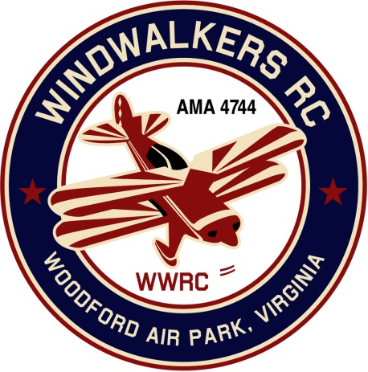
February 8, 2020
Monthly Club Meeting Minutes,
Club President, Gary Stone, called the meeting to order at 11:15 a.m. on February 8, 2020. The meeting was held at Salem Library in Fredericksburg, VA. The meeting was opened with the pledge of allegiance. There were 4 members in attendance.

Secretary’s Report:

- The meeting minutes from January 11th were read and accepted.

Treasurer’s Report:

- Beginning bank balance: $3,712.55
  - Annual Dues Deposited: $172.52
  - Checks: $75.00 Secretaries AMA Dues.
- Ending bank balance: $3,810.07

Field Safety Report:

- Nothing new to report.

Old Business:
- AMA is talking about requiring knowledge exams. Hank is going to look in to this further. Update: Nothing has happened thus far. We know we fall into proposal #3 Hank will keep up posted. (Carried to March meeting)

New Business:
- Cindy passed out a spreadsheet with AMA & FAA numbers to get members to verify they are correct. Before laminating the 2020 membership cards.
- Bill will take membership book to have (20) copies made.
- Gary passed out email from Jay Marsh, District IV. He is encouraging everyone to send letters to their congressman to save the sport. Dan suggested we invite Rob Wittman, our local congressman, to our Field Day event to discuss the new AMA rules pertaining to RC.
- Dan winterized the club lawn mower and started it up.
- We will pick dates for the following events in 2020., during the March meeting.
  - Scout Day
  - Aviation Day
  - Field Maint Day
  - SWAP Date?

Upcoming Events:

- Nothing to report currently.

There being no further business, the meeting was adjourned at 11:45 a.m.

Respectfully Submitted,

Cindy Stone

